From: https://blogs.wsj.com/riskandcompliance/2015/02/10/browder-escapes-subpoena-attempt-after-daily-show-interview/

Browder Escapes Subpoena Attempt After ‘Daily Show’
By
Samuel Rubenfeld
Feb 10, 2015 7:35 pm ET
0 COMMENTS
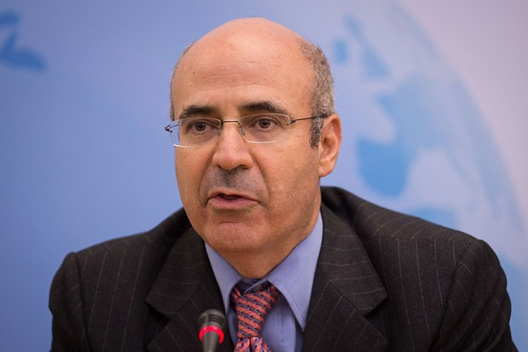
AGENCE FRANCE-PRESSE/GETTY IMAGES

Chief Executive Officer and co-founder of the investment fund Hermitage Capital Management Bill Browder attends the “Prospects for Russia after Putin” debate in London on Nov. 18, 2014.
Updated
Hedge fund manager Bill Browder escaped a “notice” of his own.
The author of “Red Notice,” a book about Mr. Browder’s experiences investing — with wild highs and extreme lows — in Russia, has been resisting a subpoena from defense lawyers seeking to depose him in a lawsuit filed by U.S. prosecutors alleging money laundering by a Russian businessman. The case is linked to the central plot of Mr. Browder’s book: His tax lawyer died in Russian custody after exposing an alleged tax fraud, the money of which was allegedly laundered across the globe. The latest attempt to serve Mr. Browder was last week as he left an interview taped for Comedy Central’s “The Daily Show” to promote his book, according to court filings.
In a court filing, Nicholas Casale, of private investigations firm Casale Associates, said he served the subpoena outside the studio in New York at 6:44 p.m. on Feb. 3, after Mr. Browder completed the interview promoting his book. Mr. Casale placed the papers in the arm of Mr. Browder, who let them fall to the backseat of the vehicle, according to the filing. Mr. Browder then tried to close the door of the vehicle, and called to the driver to open the opposite side door, the filing said. He then exited the vehicle and fled on foot, it said.
It was caught on video and posted to YouTube. In the video, Mr. Casale identifies himself and presents the papers to Mr. Browder as he runs to the passenger-side door of a waiting car.
“You have been served,” Mr. Casale said in the video.
A woman outside the frame can be heard saying: “He’s running away. Are you serious?”
Mr. Casale confirmed to Risk & Compliance Journal it was him in the video serving the subpoena, declining to comment further.
Randy Mastro, a lawyer for Mr. Browder, didn’t return a request for comment.
Update: Mr. Mastro responded to the subpoena attempt in a letter to the judge, calling the move “highly aggressive” and a “harassing, outrageous assault.”
“The experience was nothing short of harrowing for Mr. Browder, who has already submitted an unrebutted declaration detailing legitimate concerns for his personal safety, including specific, credible kidnapping threats against him reported to him last summer by the U.S. Attorney’s Office, and who had just minutes before finished a television appearance in which he sharply criticized Russian President Vladimir Putin,” he said.
The dramatic twist is the latest attempt to depose Mr. Browder by lawyers of Denis Katsyv, who is accused by the Manhattan U.S. attorney’s office of laundering some of the proceeds of an alleged $230 million tax fraud in Russia exposed by deceased lawyer Sergei Magnitsky. [The ensuing deposition makes it clear that Magnitsky had never gone to law school and never passed a bar exam.] Prosecutors say Mr. Katsyv, through companies he owns, including Cyprus-based real estate firm Prevezon Holdings Ltd., used some of the laundered money to buy real estate in New York sought in a forfeiture lawsuit filed in September 2013. Mr. Katsyv, through his lawyers, has denied the allegations and has sought to dismiss the case.
Lawyers for Mr. Katsyv say a federal agent identified Mr. Browder as “the chief source of information” for the complaint filed by prosecutors against Mr. Katsyv and his companies. This wasn’t their first attempt to serve him with a subpoena, the lawyers said.
“Mr. Browder has been resisting our every effort to cross-examine him about the case he purportedly put together,” said Mark Cymrot, a partner at BakerHostetler, in an email.
The Manhattan U.S. attorney’s office didn’t respond to a request for comment. A hearing in the case to determine whether Mr. Browder must submit to a deposition and produce documents is scheduled for March 9.
Write to Samuel Rubenfeld at Samuel.Rubenfeld@wsj.com. Follow him on Twitter @srubenfeld.

